 | 26.10.23 Editors - Properties Editor - Particle Properties Tab - Hair - Viewport Display panel
Table of content
Viewport Display 1
Display as 1
None 1
Rendered 1
Point 2
Circle 2
Cross 2
Axis 2
Color 2
Fade Distance 2
Amount 2
Show Emitter 2
Size 2
Strand Steps 3

Viewport Display
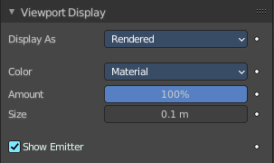
How to display the particles in the 3d viewport.

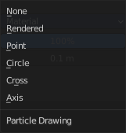
Display as
How to display the particles in the viewport.

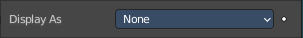
None
Don't display particles in the viewport.

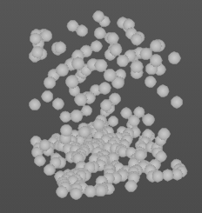
Rendered
Display the particles as rendered.
Important! These settings are dependent of the render as mode in the Render panel, and some settings just displays in the right mode.

Point
Display the particles as Points.

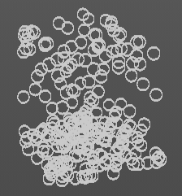
Circle
Display the particles as circles.

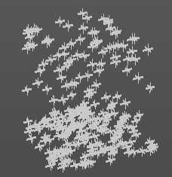
Cross
Displays each particle as a cross.

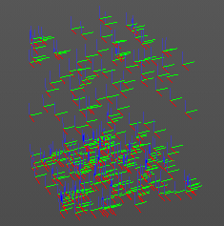
Axis
Displays each particle as an axis widget.

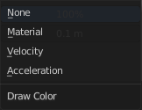
Color
What draw color to use for the particles.

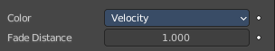
Fade Distance
With color mode Velocity and Acceleration. Maximum length of the particle color vector.

Amount
Percentage of particles to display in the 3d viewport. Choosing a display percentage lower 100 makes dynamics inaccurate without baking.

Show Emitter
Render the particle emitting mesh.

Size
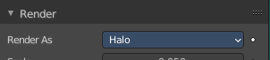
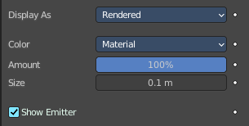
Shows with render method Halo. Size of particles in viewport in Blender Units.

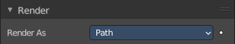
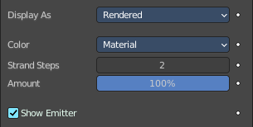
Strand Steps
Shows with render method With Path. How many steps paths are drawn with. The value needs to be a power of two.

